Module 13: Public Performance & Overcoming Stage Fright

storytelling a confident and engaging experience
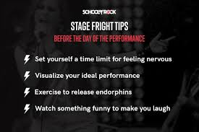
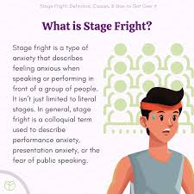
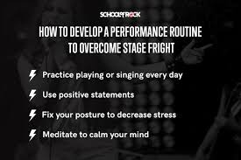


Mzansi@, this module is a gift to every hesitant voice — it transforms vulnerability into power. It’s practical, compassionate, and deeply aligned with your mission to nurture confident, expressive storytellers. Here’s the full metadata suite for Module 13: Public Performance & Overcoming Stage Fright, with entrepreneurial relevance embedded through public speaking, audience engagement, and personal branding:

Module Metadata: Public Performance & Overcoming Stage Fright (1 Hour)

Short Description
Storytelling is a public art, and performing in front of an audience can be intimidating. Many storytellers face psychological barriers, such as stage fright, self-doubt, and fear of judgment. However, with strategies for confidence and presence, anyone can overcome these challenges and deliver compelling performances.
Build confidence in public storytelling. This module helps learners overcome stage fright, self-doubt, and fear of judgment through practical strategies, mindset shifts, and performance exercises — empowering them to share stories with presence and impact.

Long Description
Storytelling is a public art — and every voice deserves to be heard. In this module, learners will explore the psychological barriers that often accompany performance, including anxiety, perfectionism, and fear of judgment. They’ll learn proven strategies for building confidence, engaging audiences, and embracing imperfection. Through breathing drills, mirror practice, and gradual exposure, learners will develop the skills to perform with authenticity and emotional resonance. These techniques support not only personal growth but also professional storytelling in education, media, leadership, and entrepreneurship.

Aims
- To help learners overcome psychological barriers to public storytelling.
- To provide strategies for building confidence, presence, and audience connection.
- To highlight how performance skills support storytelling careers and creative enterprise.

Objectives
By the end of this module, learners will be able to:
- Identify common fears and barriers in public storytelling.
- Apply techniques such as rehearsal, breathing, and positive self-talk to manage stage fright.
- Engage audiences through eye contact, interaction, and emotional presence.
- Reflect on how public performance enhances storytelling impact and professional visibility.

Learning Outcomes
Learners will:
- Demonstrate confidence in storytelling through live performance.
- Apply strategies to manage anxiety and build stage presence.
- Perform stories with emotional resonance and audience engagement.
- Begin to position public storytelling as a tool for leadership, branding, and creative entrepreneurship.

The Psychological Barriers of Storytelling
Fear of public performance often stems from:
- Stage Fright – Anxiety about speaking in front of an audience.
- Self-Doubt – Worrying about making mistakes or forgetting the story.
- Fear of Judgment – Concern about how the audience will react.
- Perfectionism – Feeling pressure to deliver a flawless performance.
These barriers can be managed and overcome through preparation and mindset shifts.
Strategies for Confidence and Presence
- Rehearsal & Preparation
  - Practicing repeatedly reduces fear and builds confidence.
  - Rehearse in front of friends or family before performing publicly.
- Breathing & Relaxation Techniques
  - Deep breathing calms nerves and improves focus.
  - Visualization exercises help mentally prepare for the performance.
- Positive Self-Talk
  - Replace negative thoughts with affirmations (e.g., “I am prepared and capable”).
  - Focus on sharing rather than performing perfectly.
- Gradual Exposure
  - Start with small audiences and gradually increase performance size.
  - Participate in low-pressure storytelling events to build confidence.
- Engaging with the Audience
  - Make eye contact to establish connection.
  - Use interactive elements (e.g., asking questions, involving listeners).
- Embracing Mistakes
  - Mistakes are part of storytelling—learn to recover gracefully.
  - Laugh off errors and keep the story moving.
Live Performance Exercises
- Mirror Practice
  - Objective: Improve facial expressions and confidence.
  - Activity: Tell a story while watching yourself in a mirror.
- Gradual Exposure Challenge
  - Objective: Reduce stage fright.
  - Activity: Perform a short story in front of one person, then a small group, then a larger audience.
- Breathing & Visualization Drill
  - Objective: Manage anxiety before performing.
  - Activity: Practice deep breathing and visualize a successful performance.
- Audience Interaction Exercise
  - Objective: Strengthen engagement.
  - Activity: Incorporate questions, chants, or call-and-response into storytelling.
Expanding on "I Am Shy, How Can I Tell Stories?"
Yes, rehearsals are designed to counteract fear of the stage and audience. Here’s how shy storytellers can build confidence:
- Start Small – Practice storytelling alone or with close friends.
- Use Familiar Stories – Choose stories you love and feel comfortable telling.
- Focus on the Message – Shift attention from yourself to the story’s impact.
- Practice in Safe Spaces – Perform in supportive environments before larger audiences.
- Celebrate Progress – Every performance, no matter how small, builds confidence.
Shyness does not mean you can’t be a great storyteller—it simply means you need gradual exposure and practice to feel comfortable.
Exercise: Identify three strategies for managing stage fright and test them while telling a story.
Assignment: Perform a story in front of a larger audience and reflect on your experience.

